Geometry: Unit 11, Lesson 5

- Given $m∠GPW=95.2°$, $m∠NRP=136.8°$, and $m∠SWR=(3x-3.4)°$, if the sum of the three angles equals $360°$, what is the value of $x$?

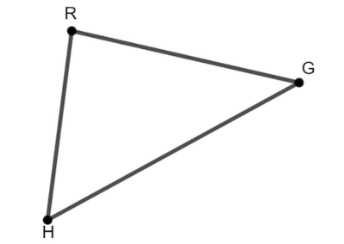
- Triangle $RGH$ is shown, where $m∠RGH=\left(5x+1\right)°$, $m∠GHR=\left(6x+6\right)°$, and $m∠HRG=\left(11x-3\right)°$. What equation can be used to find the value of $x$?

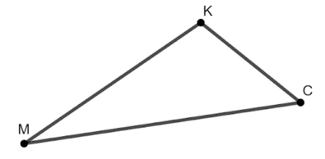
- Triangle $MKC$ is shown, where $m∠KMC=26°$ and $m∠MCK=47.3°$. What is the $m∠CKM$?

